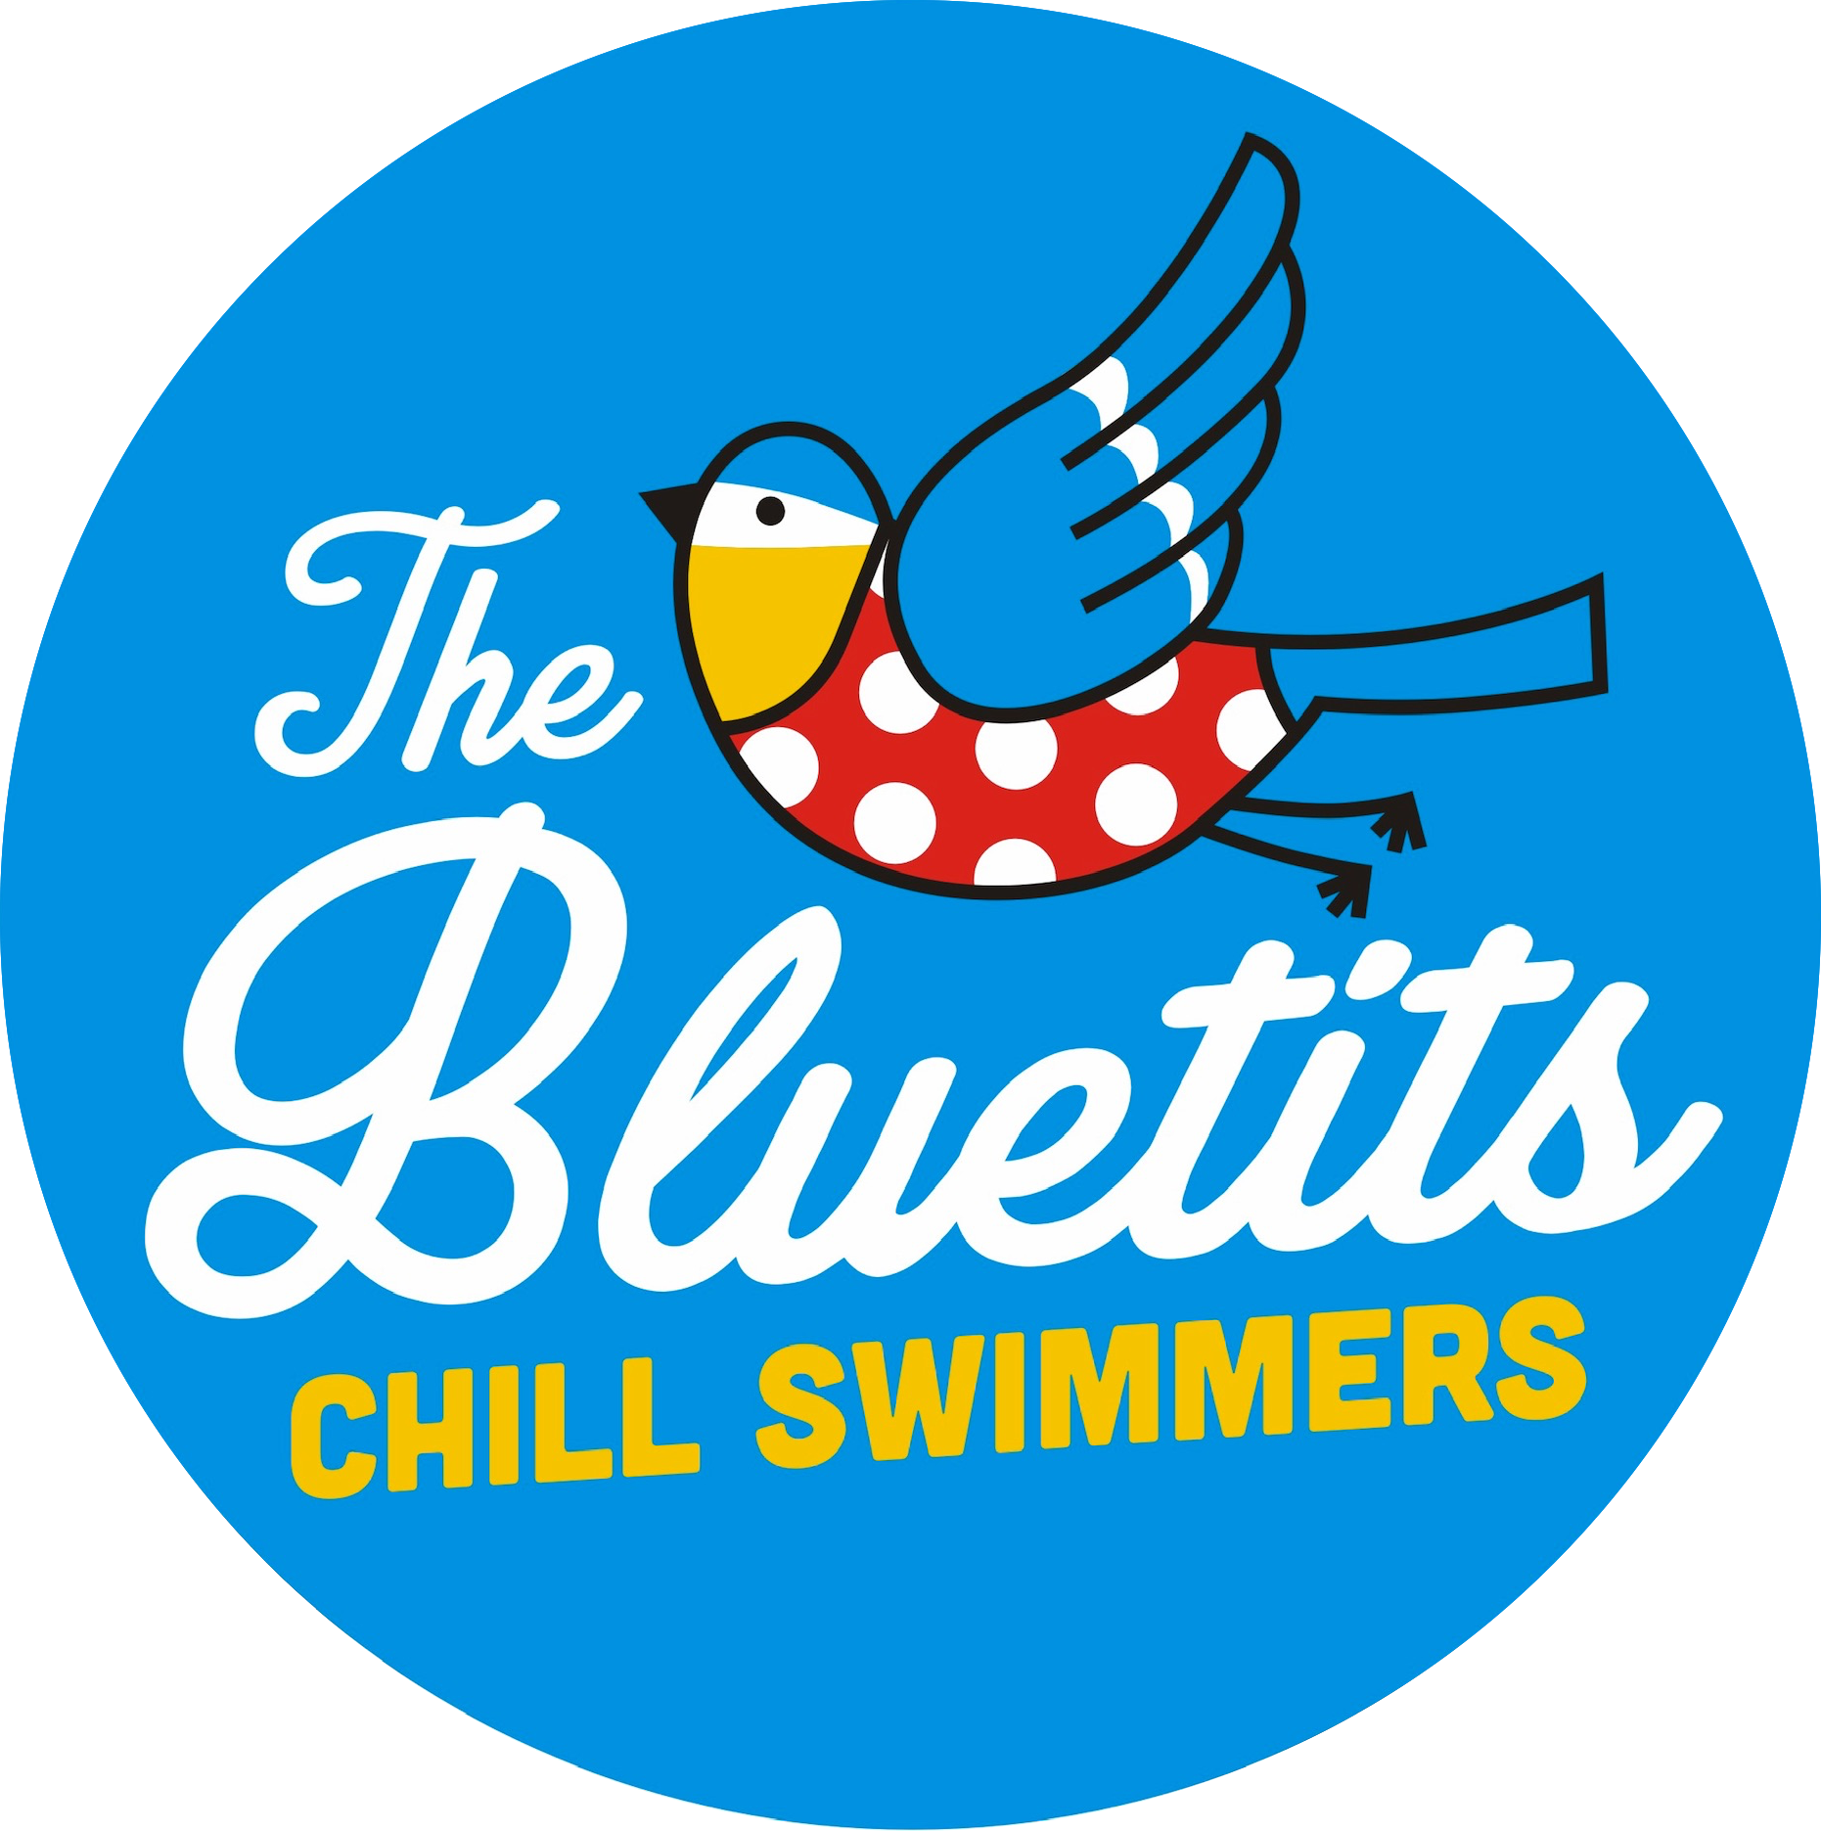

**Activity Consent Form**

All participants in Bluetits Chill Swimmers Guided Activities are required to complete a registration form.

|  |  |
| --- | --- |
| Date of Activity |  |
| Full Name |  |
| Home Address |  |
| Email |  |
| Phone |  |
| Emergency Contact |  |
| Medical conditions or disabilities that our Guides need to be aware of. e.g. asthma, heart conditions, epilepsy, diabetes, allergies. |  |
| Medication that you need to carry with you. |  |
| Can you swim 25 metres unaided? |  |
| Have you swum in open water? |  |
| Statement of Risk | Our activities may involve walking, bending, lifting, balancing, stretching, coordination and swimming. In case of any doubt please consult your GP before booking.  Adventurous activities involve some risks for those taking part and we aim to keep these risks as low as possible.  We expect participants to co-operate with all our staff to ensure the safety of all participants, by following instructions and answering questions honestly. |
| Photography, Marketing and Data | We take photos and occasionally footage of our activities and participants. Do you agree to us using anonymous images and footage of you during the activities?  I understand that information from this activity may be stored digitally. |
| Confirmation and Consent | I confirm that as the participant I am fit to participate in the activities I have booked. I accept that by their nature, adventure activities may involve some level of risk which cannot be fully eliminated and I consent to taking part in all activities. In the event of any illness or accident I consent to any necessary medical treatment. |
| Signed  Print Name |  |
| Date of Activity |  |
| Email address(to be kept up to date with occasional news from The Bluetits Chill Swimmers Ltd) |  |